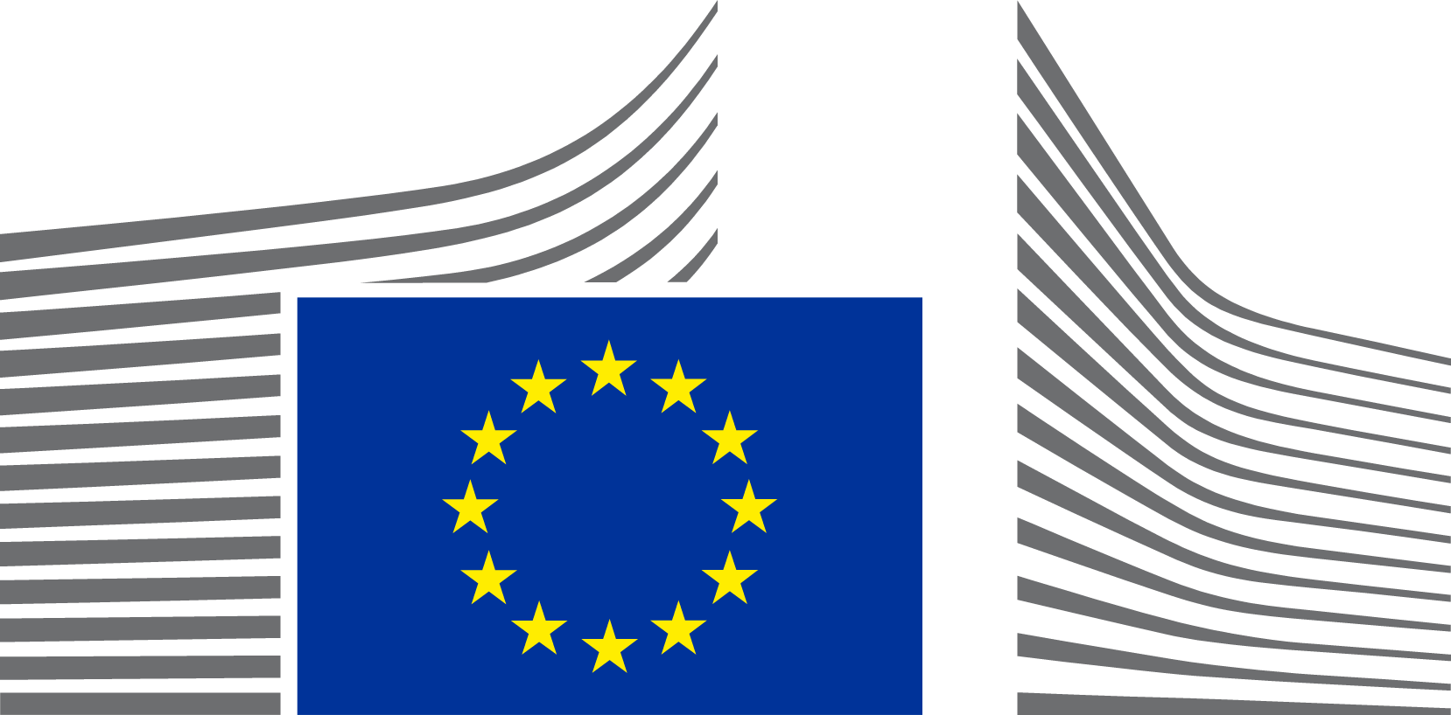 | EUROPEAN COMMISSION  DIRECTORATE-GENERAL FOR COMMUNICATIONS NETWORKS, CONTENT AND TECHNOLOGY  Data

Contact points for Estonia in TwinIt! 3D for Europe’s Culture, 2023-2024

Kristiin Meos | National Heritage Board  Ministry of Culture | kristiin.meos@kul.ee

